This version of EATool was designed in response to recent security measures that blocked the use of macros in Microsoft Office. Unlike the older version, this EATool requires more manual entry and works like a typical spreadsheet. The fields won’t automatically update according to your selections (for instance, all alternatives will be visible even if the only feasible alternatives in your project are the Status Quo and Alternative A), and this file does not accept the data text files like the old version.

The first screen that opens will be where you designate the project life, the base year, the feasible alternatives, etc. Please use the drop down menus to select each value.

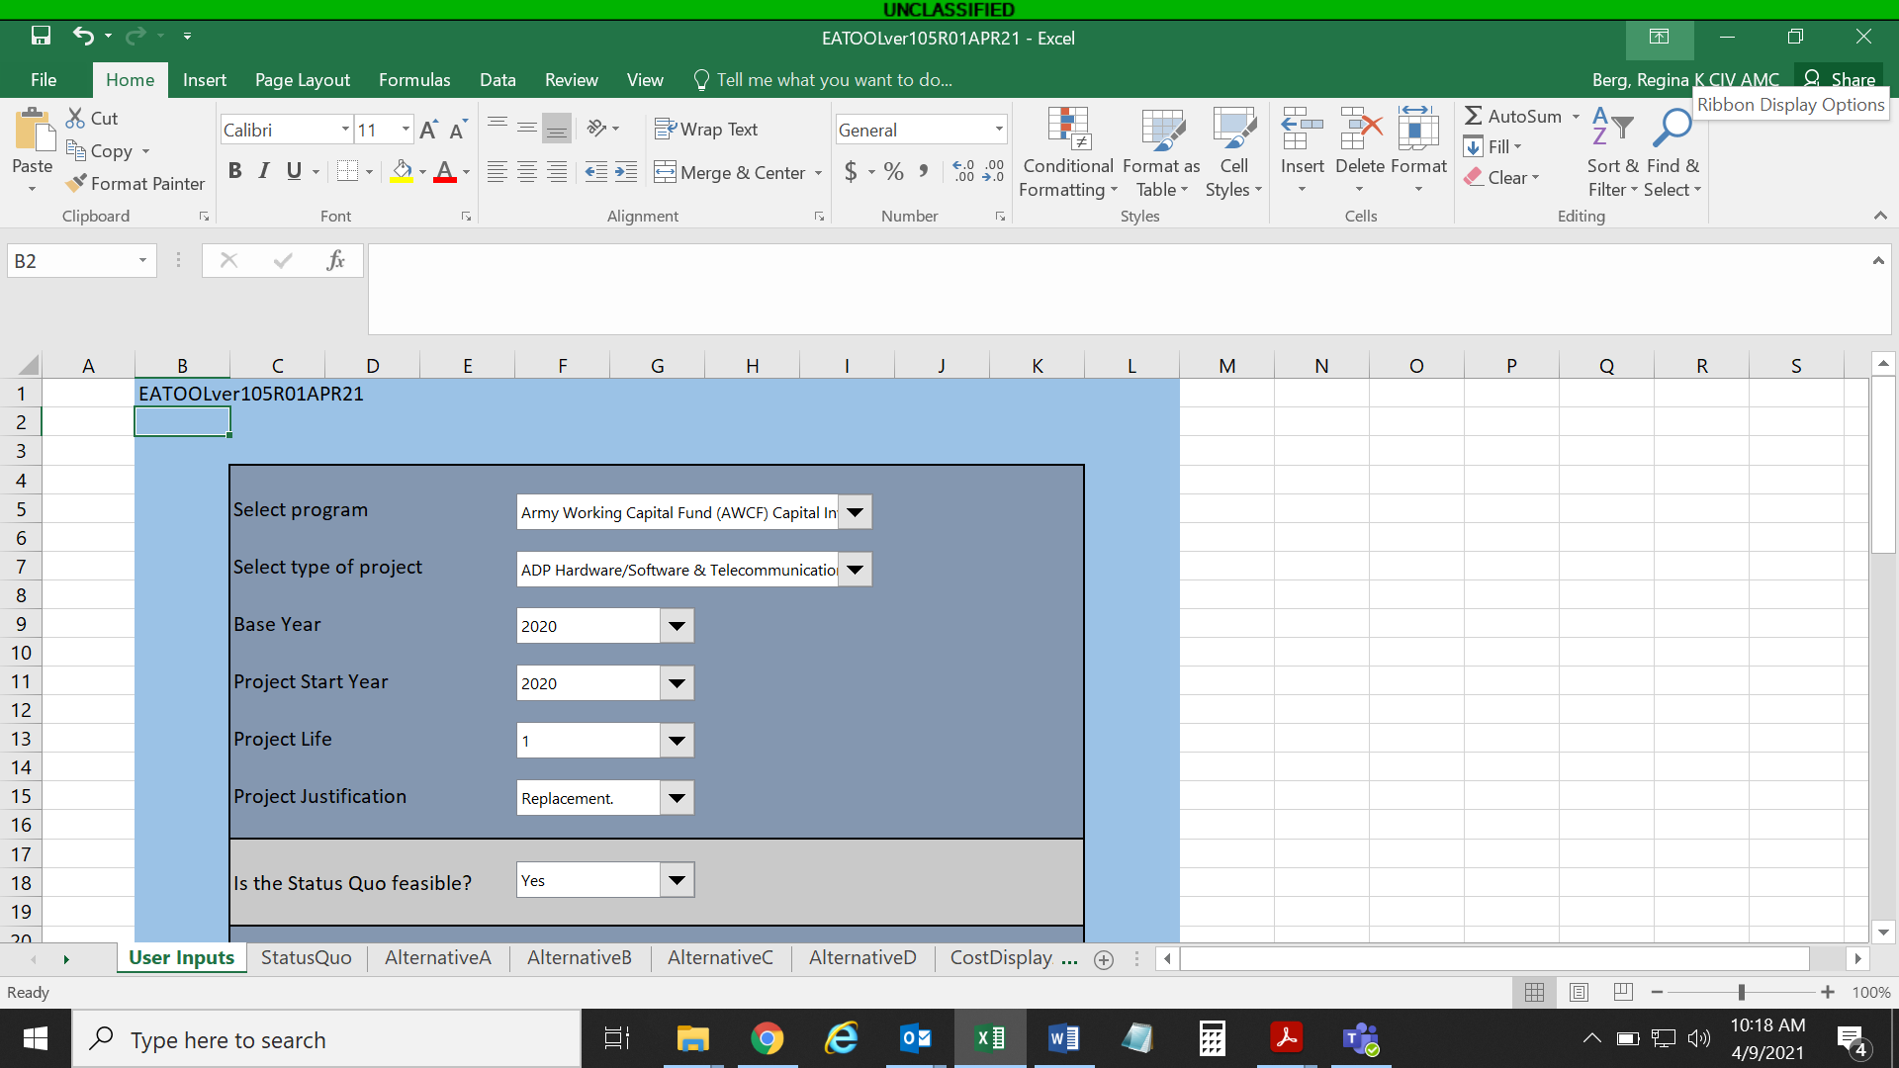

*Use drop-down menus to select type of project, base year, project start year, project length of life, project justification reason, whether the Status Quo is feasible (usually “yes”) and the most relevant cost funding type.*

Scroll down to see additional available alternatives and make selections on whether they are feasible (most EA’s will have a feasible Status Quo and Alternative A; sometimes additional alternatives are also feasible for a more thorough analysis) and if so, select the most relevant funding types.

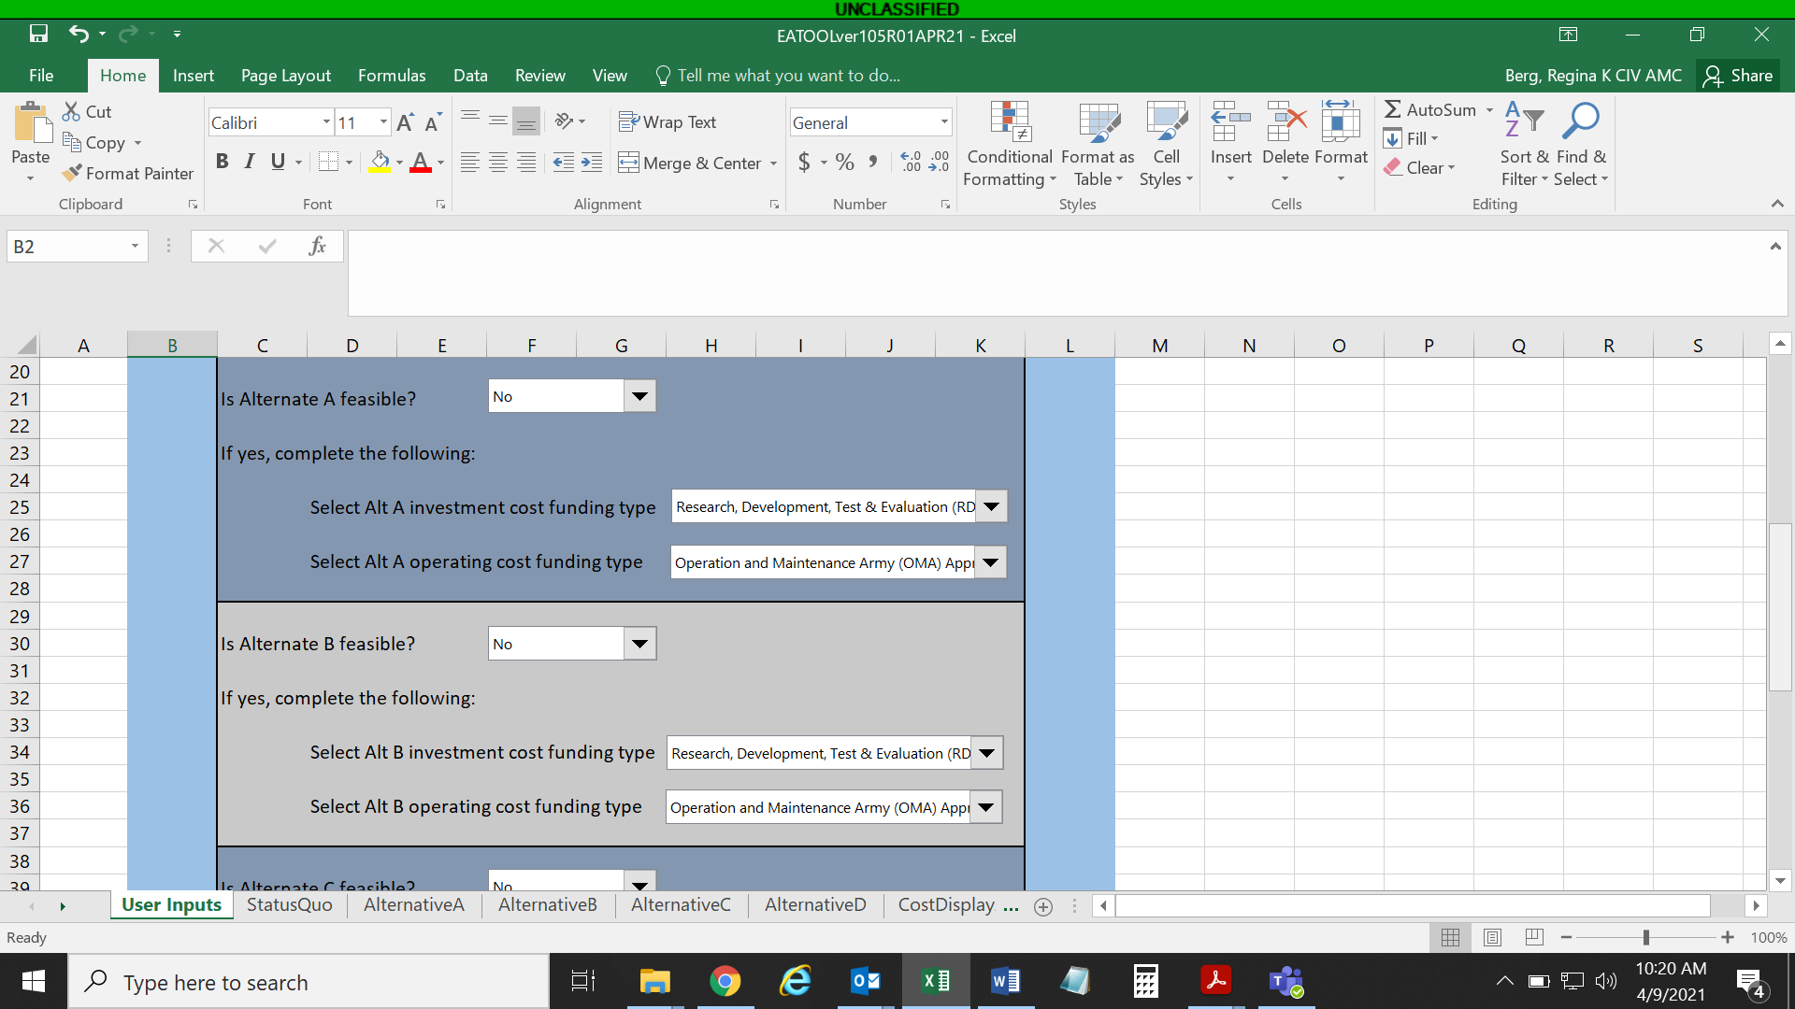

*Use drop-down menus to select whether an alternative is considered in the analysis and if so, the most relevant cost funding type.*

Next, go to the Status Quo tab, Alternative A tab, etc., for each feasible alternative and enter the operating/sustainment costs, investment cost, and any one-time costs.

**Status Quo**:

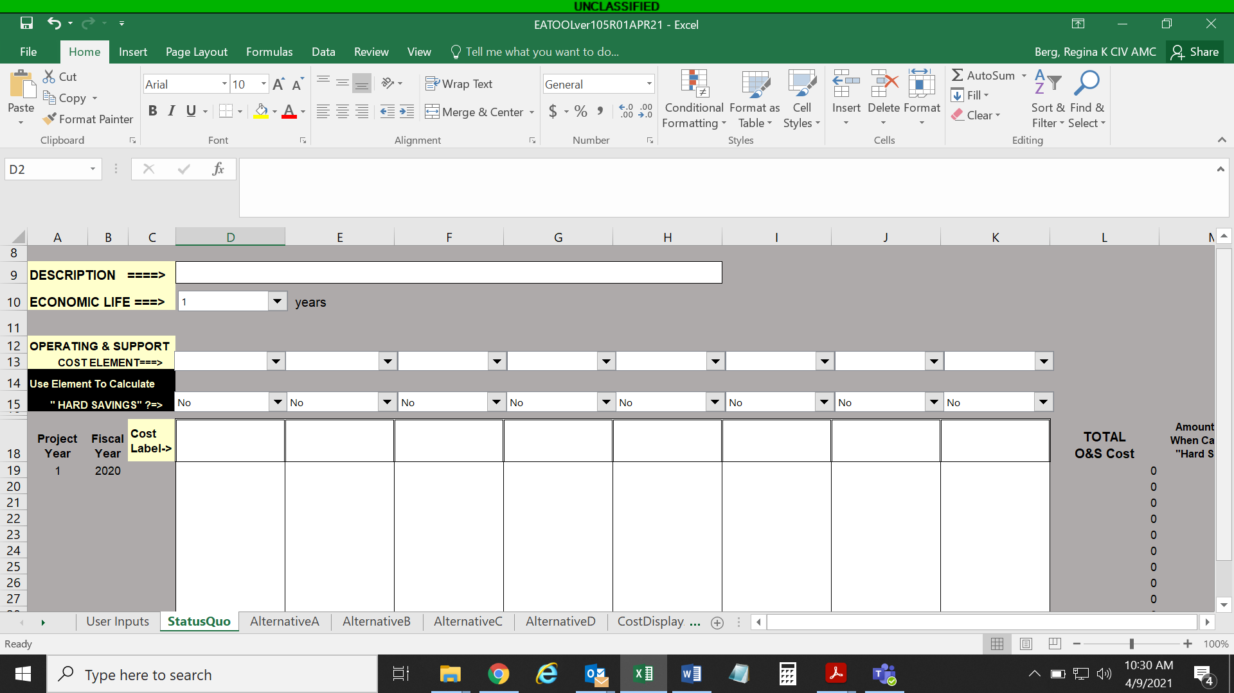

*Select the O&S Cost Element, type a Cost Label (“unplanned maintenance”, “labor”, etc.), and enter costs by year.*

**Alternative(s)**:

*Select the Investment Cost Element, type a Cost Label (“equipment”, “training”, etc.), and enter costs by year (typically only 1 year of data is entered).*

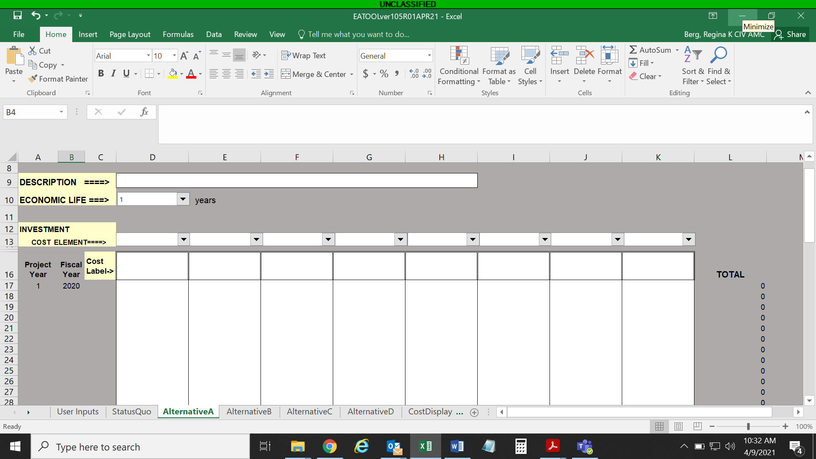

(scroll down for Alternative operating costs)

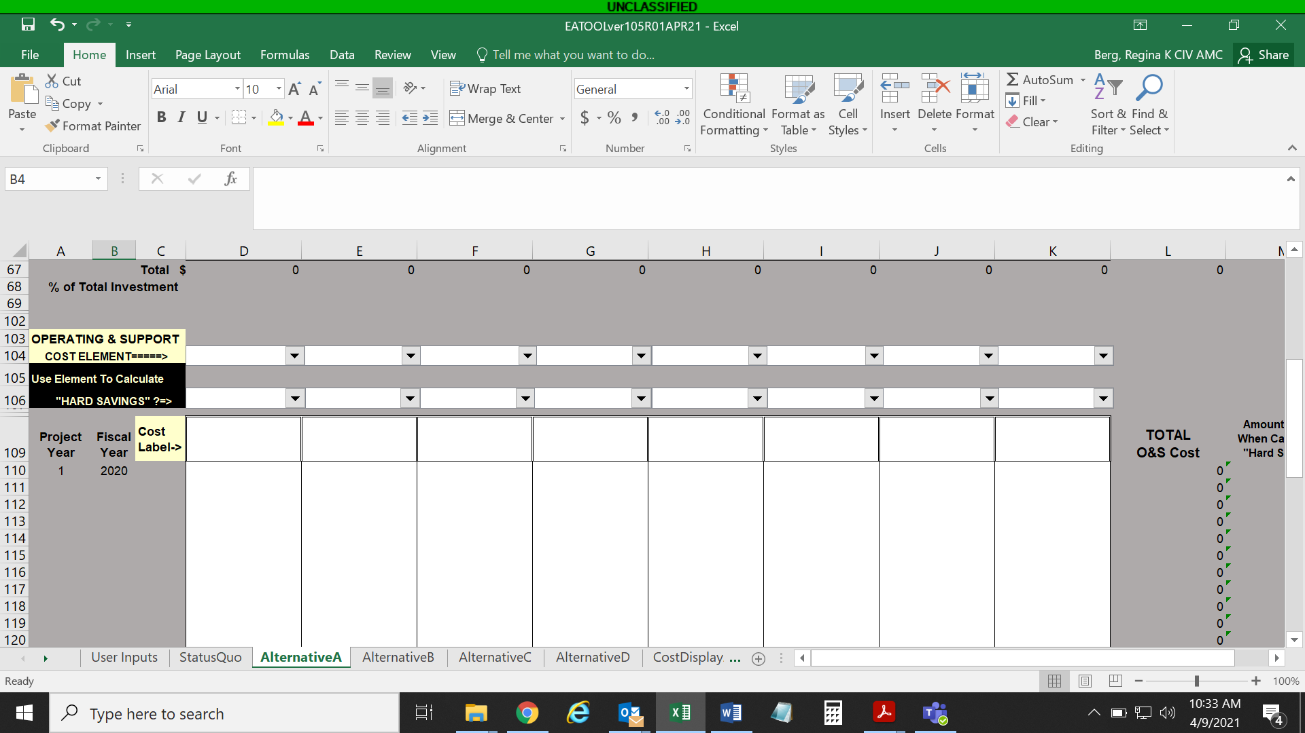

*Select the O&S Cost Element, type a Cost Label (“preventative maintenance”, “labor”, etc.), and enter costs by year.*

Summary information can be found on each CostDisplayA, CostDisplayB, etc. tabs. Also a final summary can be found on the ComparisonOfAlternatives tab. A screenshot can be taken for each of these summaries to include in the EA narrative.

*No data should be entered on this sheet; values will populate from entries on previous tabs. Cost Displays are for informational purposes only.*

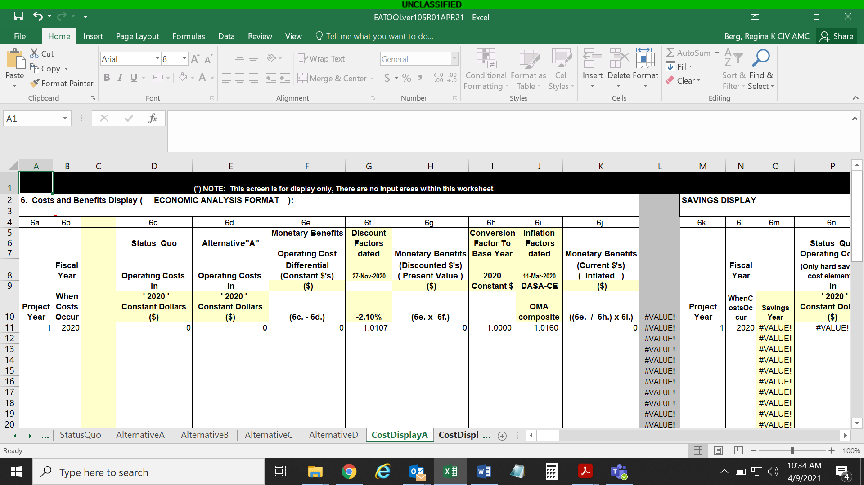

*No data should be entered on this sheet; values will populate from entries on previous tabs for feasible alternatives. A screenshot of this table should be included in the EA.*

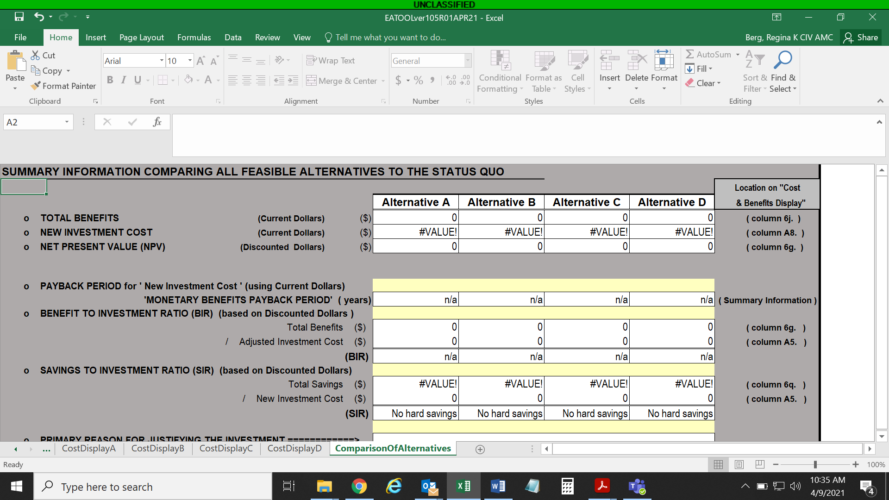

This version of EATool should be saved like you would save a typical spreadsheet; unlike the old version, changing the name of the file is acceptable and will not cause any errors or issues. Each project will have its own complete spreadsheet.

*Note that opening the old version of EATool and the new version of EATool at the same time can result in an error message and the new version won’t work correctly. To copy data, open a blank spreadsheet, copy the data into the blank one, then copy it to the other version so both versions aren’t open at the same time.

2021 will be the first full year of fielding this revamped version of EATool. If users notice any discrepancies in using this version as compared to the older version with macros, please send notification to regina.k.berg.civ@mail.mil.